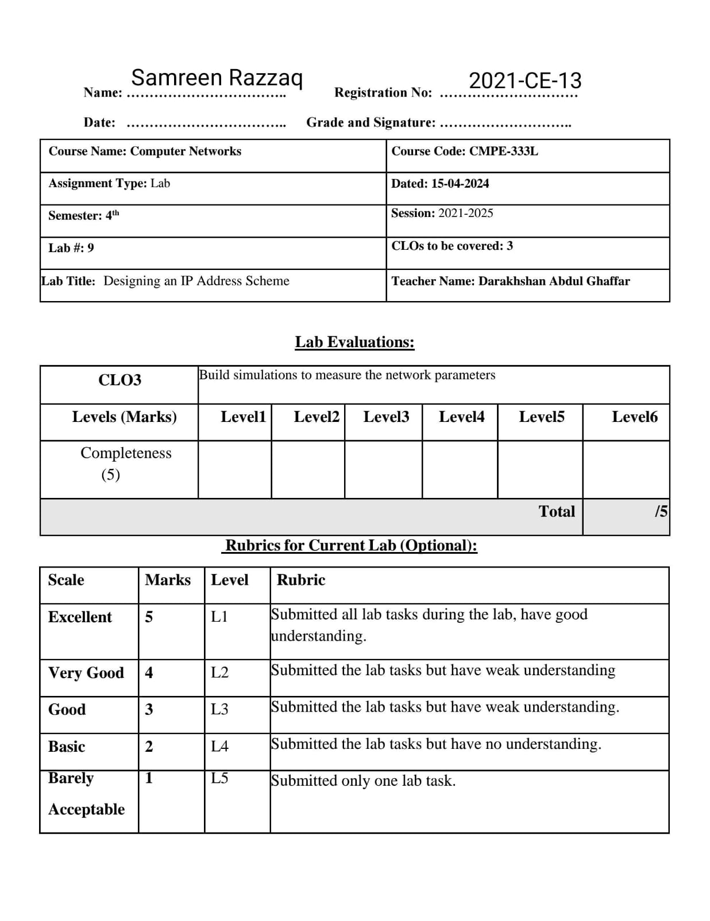

**Exercise 1**

Company ABC has 100 workstations in their head office and the IT manager would like to assign

a subnetwork address for each department. He wants to create 5 subnets using the 192.168.1.0/24

block and assign the first subnetwork to their servers and the rest for their 100 workstations. How

will we compute the subnetwork requirement?

Given:

Number of workstations = 100

Network address = 192.168.1.0/24

Subnets required = 5

Design the network in Packet tracer and configure all routers, show packet are moving between all

subnets using pings from various attached hosts/workstations.

**Solution:**

